|  |  |  |
| --- | --- | --- |
| **Kingdom of Saudi Arabia**  **Ministry of Education**  **Prince Sattam Bin Abdulaziz University**  **College of Computer Engineering and Sciences**  **Department of Information Systems** |  | **وزارة التعليم**  **جامعة الامير سطام بن عبد العزيز**  **كلية هندسة وعلوم الحاسب**  **قسم نظم المعلومات** |

Database Administration -IS4511

Lab Assignment 1

NORAH MOHAMMED ALESSA

442050412

1. Check the name and the number of tablespaces in your database.

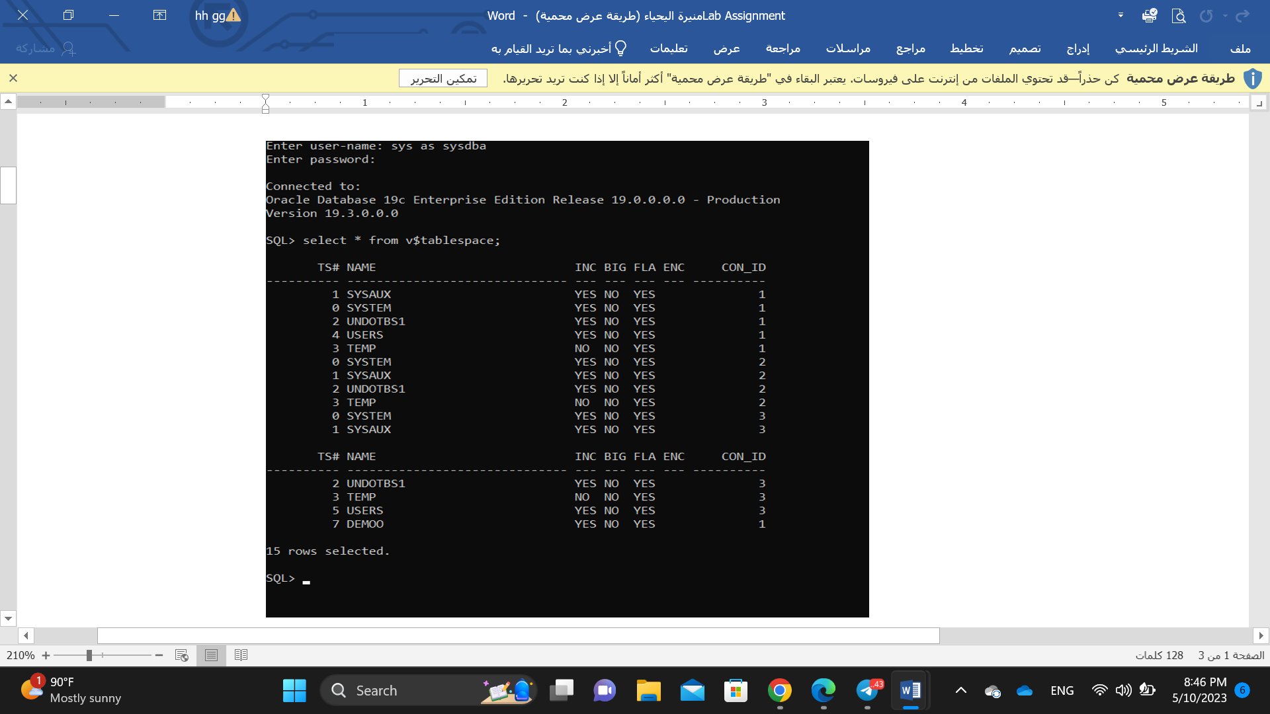

1. Create a new Tablespace ‘Mytablespace’.

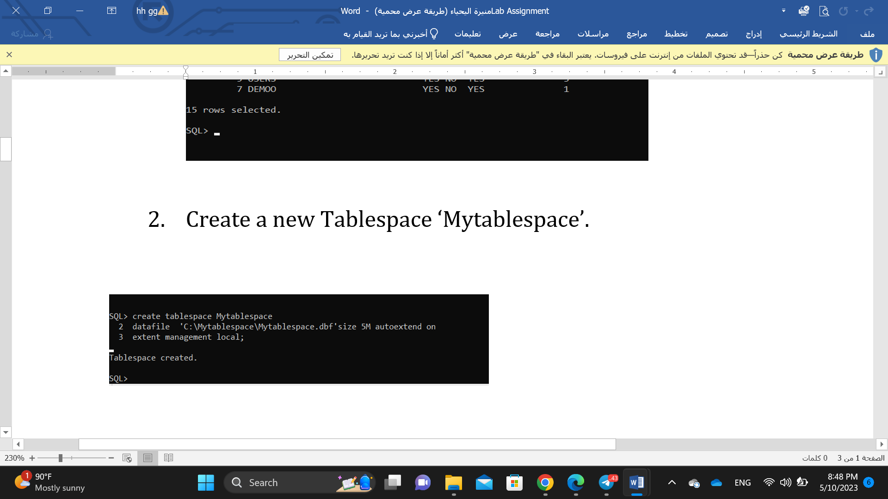

1. Make the Tablespace offline.

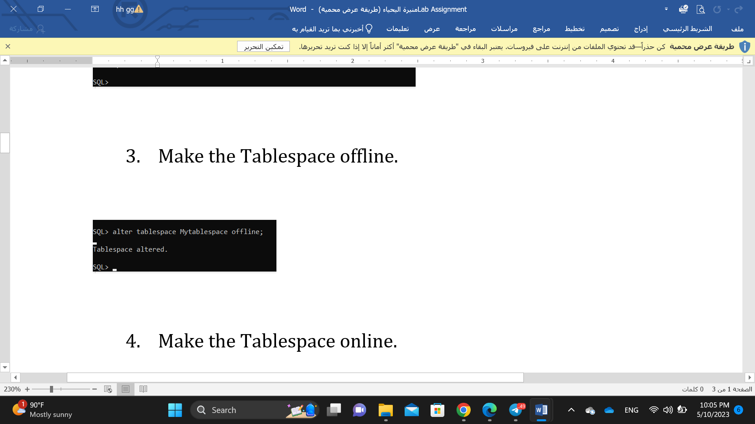

1. Make the Tablespace online.

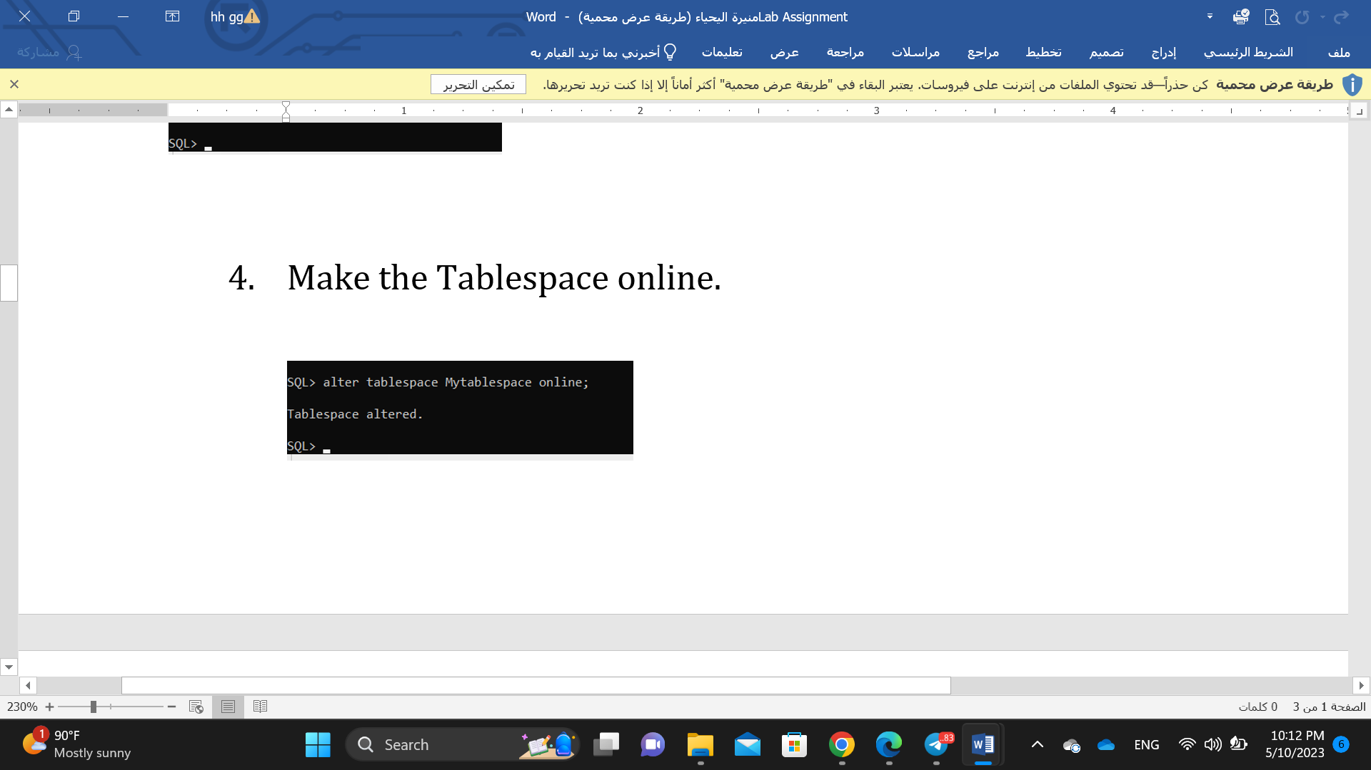

1. Add new data file into ‘Mytablespace’ Tablespace.

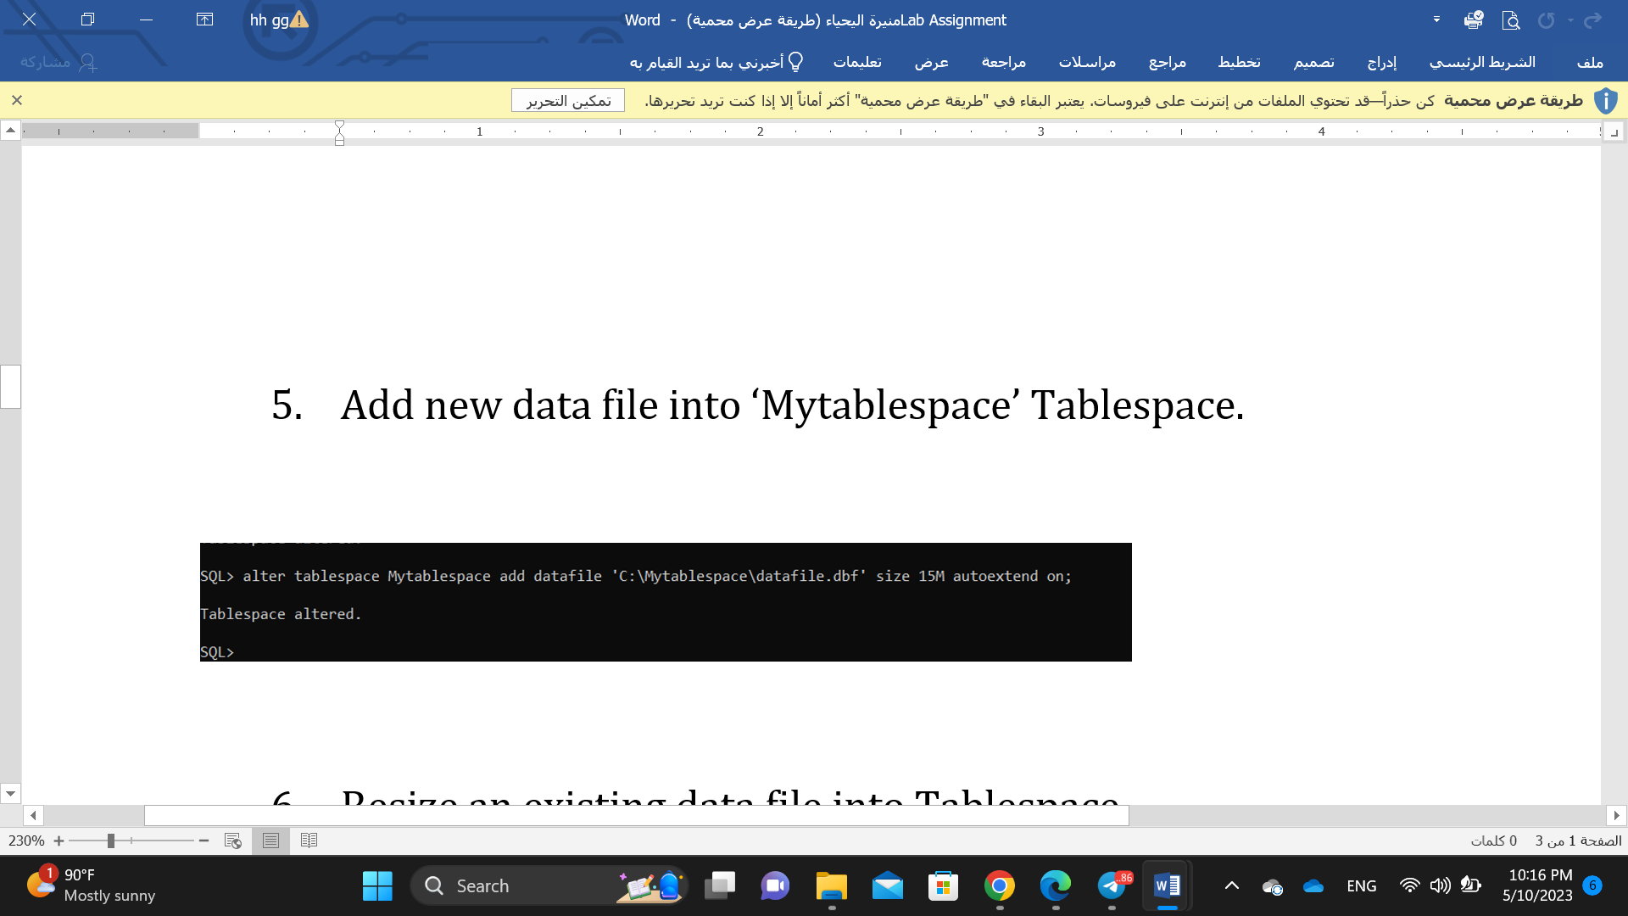

1. Resize an existing data file into Tablespace.

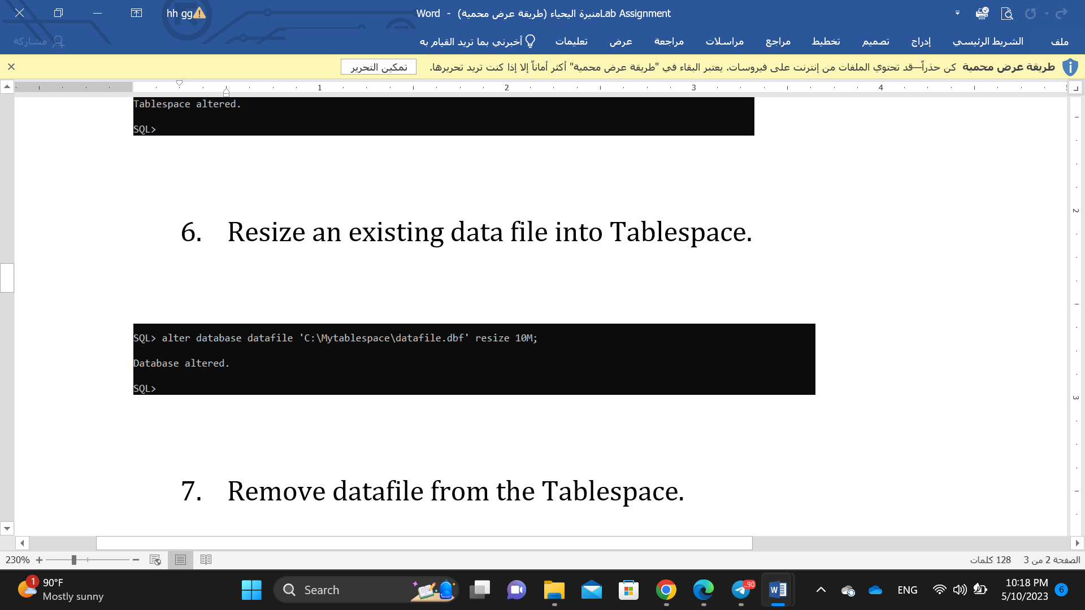

1. Remove datafile from the Tablespace.

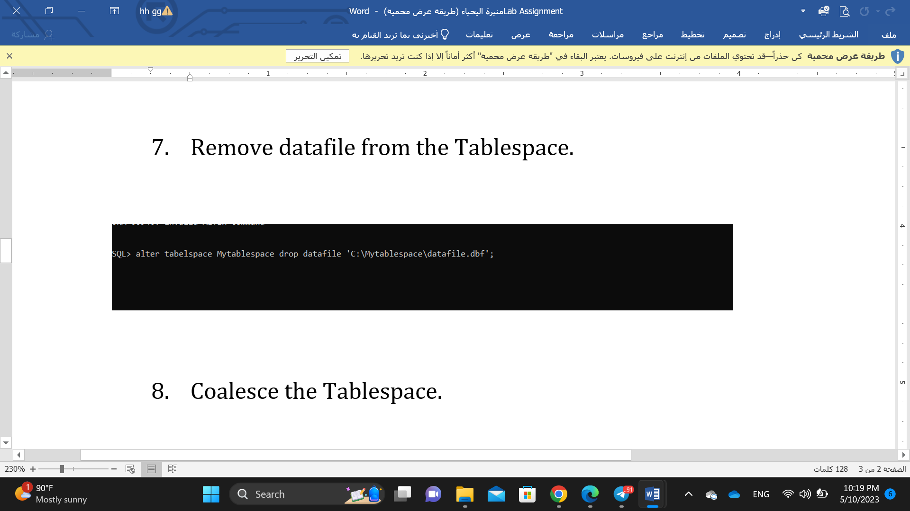

1. Coalesce the Tablespace.

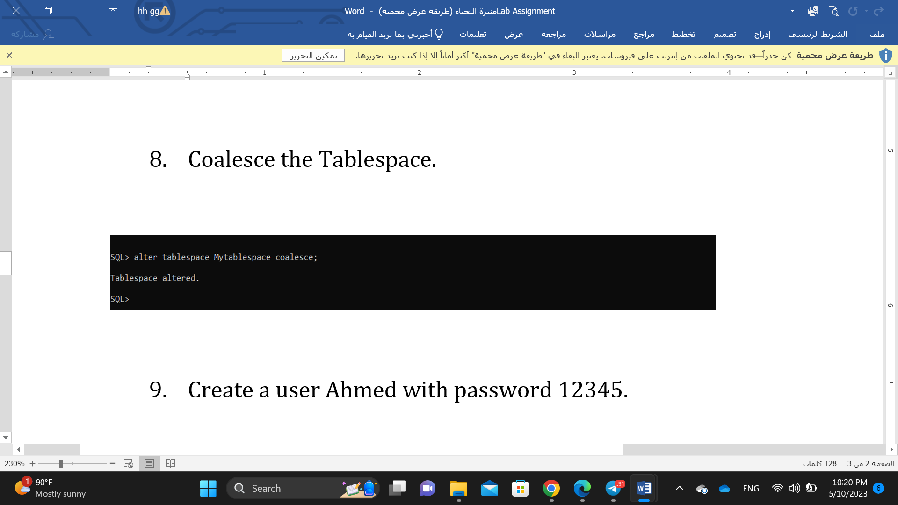

1. Create a user Ahmed with password 12345.

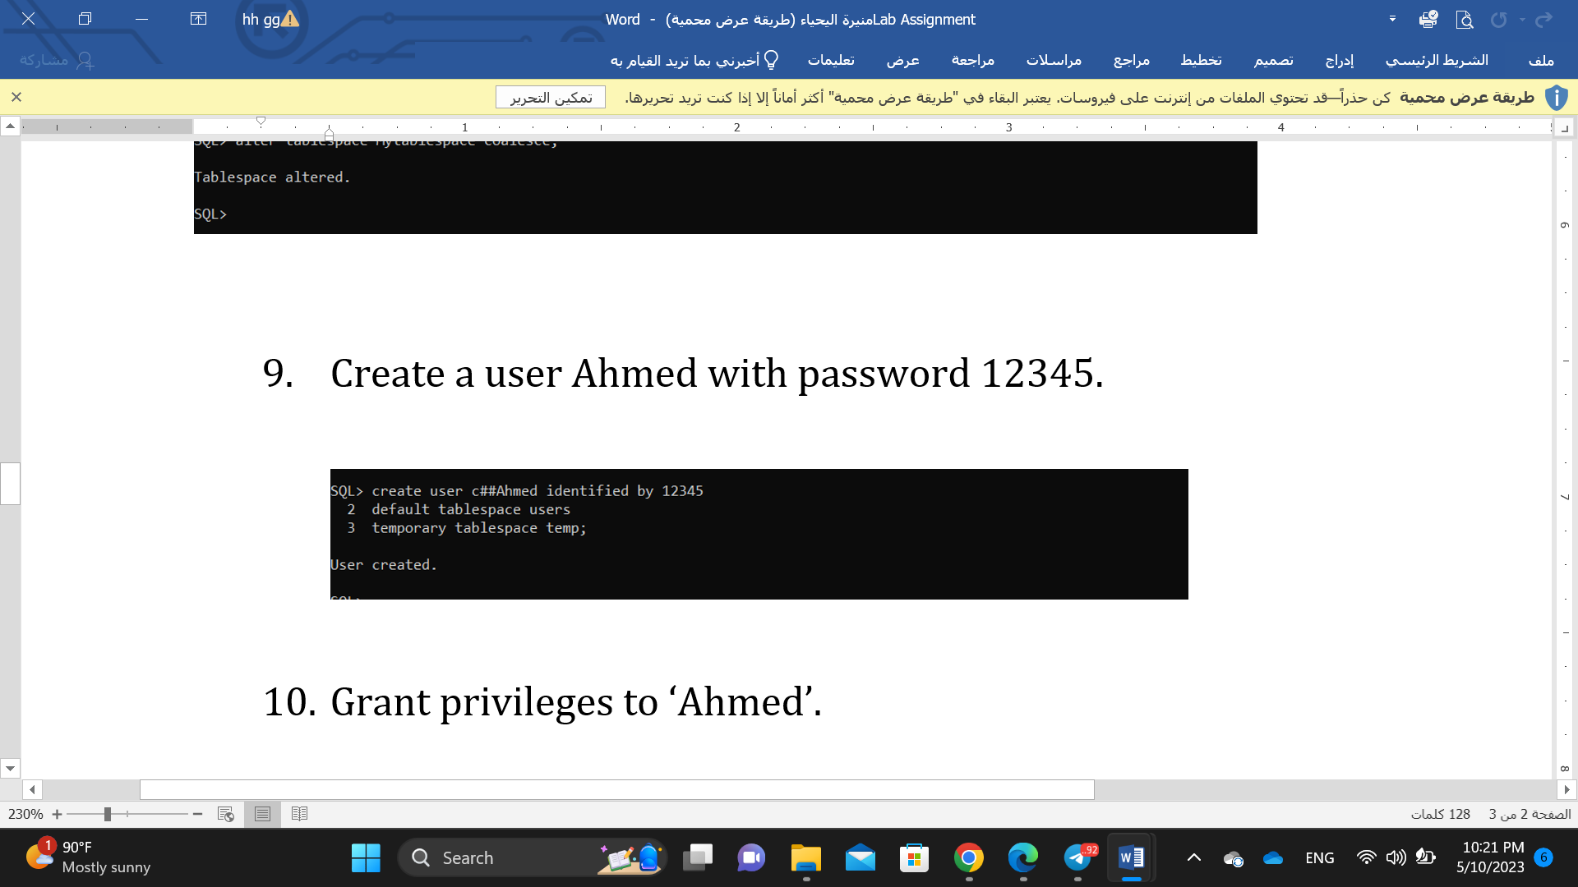

1. Grant privileges to ‘Ahmed’.

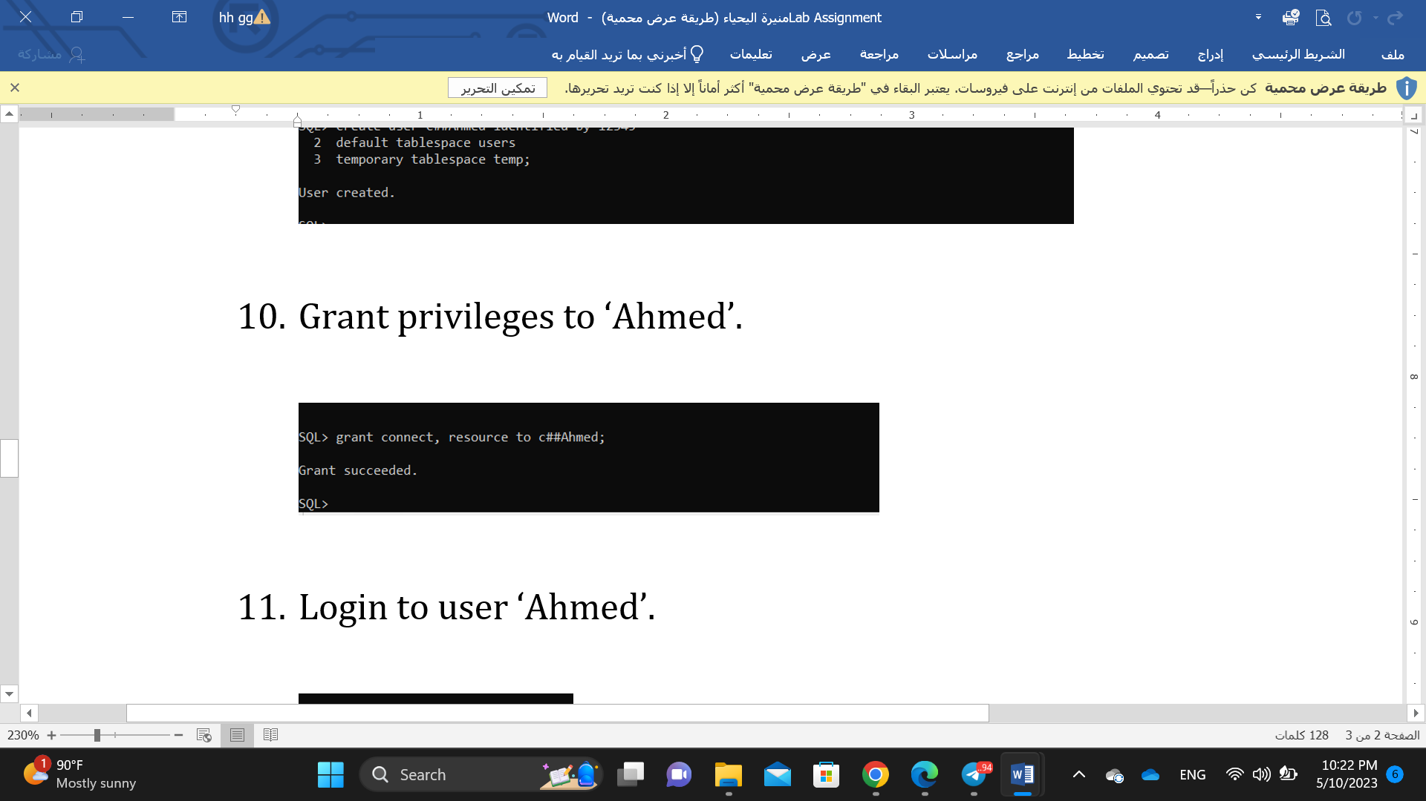

1. Login to user ‘Ahmed’.

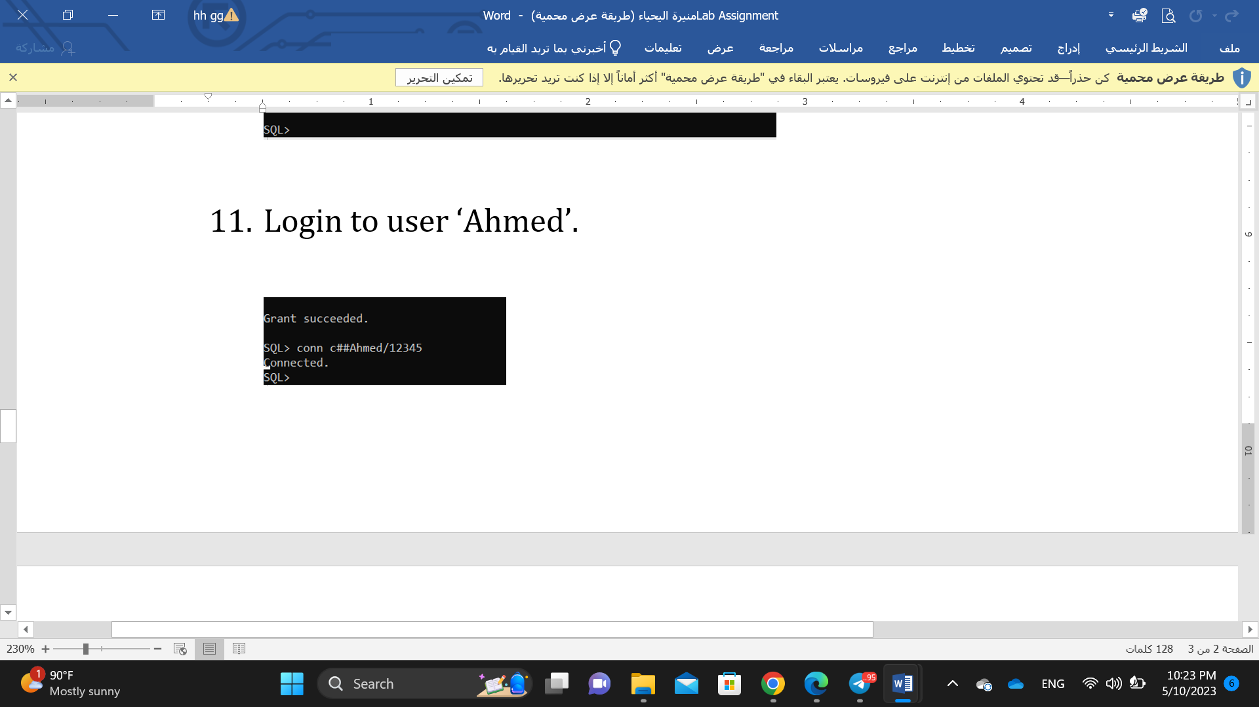

1. Revoke the privileges from user ‘Ahmed’.

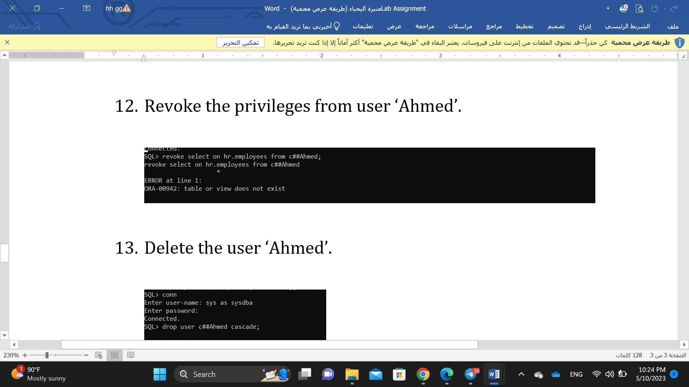

1. Delete the user ‘Ahmed’.

